**Online Gift Shop and**

**Inventory Management System**

1. **INTRODUCTION**

Organization will fall short of its purpose without proper and effective inventory of its sales & stocks. Sales & Inventory Management Systems are ways of management and monitoring all of these sales & stocks. Inventories in smaller organization are done manually, but as a business grows with its increasing number of location, department, items and transactions, making inventory and managing orders, purchase, allocation of stocks by manual means is almost unworkable. To be able to do the task, the inventory management software must be put to action.

To develop software that will help in the maintenance and management of any inventory system. This is an integrated system that covers different kinds of features like customer order, payment, billing, supplier details etc. Administrator is the user who logs in and manages the entire inventory. Report generation is done at every stage of sale as well as purchase.

The software provides following facilities to the administrator::

* Facilitates online entry of any details related to the inventory.
* Provides information about the different orders of the customers.
* Bill generation is done for every customer order.
* Inventory can be updated at any point of time.
* Supplier details are also stored in the database.
* On low stock inventory is updated by purchasing goods from the supplier.
* Master Driven approach to reduce data entry mistake.
* System can produce stock on hand report any time.
  1. **BACKGROUND**

Coming to the existing system all the works are done manually (manual process), using   
pen and paper. All the entries of the labors data are done by the manual on the book or file.   
Sometimes they have difficulty to search and find the details of labors or clients.  
Searching details or data of any labors cost many time and hard work. Information   
written on file or book can be lost as it is not stored anywhere.

**Drawbacks:**

* More Time is required in search of any data or information.
* More stationaries are required.
* Information or data can be lost as they are not stored properly.
* Cost is more because stationeries are required.
  1. **ORGANIZATIONAL PROFILE**

**Name, Address and Tel. no of the Organization:**

We are not an actual organization; we are just a group of graduation pursuing students, who chose to make this project so as to help the institutes manage their attendance records easily.

Telephone: 8879446676

E-Mail:

Mtsydv54@gmail.com

Bbaskarshetty415@gmail.com

Name & details of contact person:

Rohit R. Yadav

Baskar Francis Shetty

**Background of the Organization:**

We chose the project so as to help the educational institutes in creating, managing, and presenting the attendance records efficiently. The idea sprung after watching a report on how tedious the attendance keeping can become once the institute starts catering a huge number of students. As well as the resources spent for creating, managing and presenting the records also costs a lot (for stationary etc.).

**Vision and Goals:**

Our primary vision is to make a truly acceptable and efficient system which will be helpful to the institutions in every possible way.

**Team members name and roles assigned to them:**

we are a team of two people, Rohit yadav and Baskar Francis. Baskar has been assigned to take care of the the whole design part, and Rohit is designated to take care of the whole coding part.

The documentation part will be done by both.

* 1. **PURPOSE, SCOPE AND APPILCABILITY**

**Purpose:**

This system can be implemented to any shop in the locality or to multinational branded shops having retail outlet chains. The system recommends a facility to accept the orders 24*7 and a home delivery system which can make customers happy. If shops are providing an online portal where their customers can enjoy easy shopping from anywhere, the shops won’t be losing any more customers to the trending online shops such as flipcart or ebay. Since the application is available in the Smartphone it is easily accessible and always available.

**Scope:**

This project is a web based gift shopping system for an existing shop. The project objective is to deliver the online shopping application into android platform. Online shopping is the process whereby consumers directly buy goods or services from a seller in real-time, without an intermediary service, over the Internet. It is a form of electronic commerce. This project is an attempt to provide the advantages of online shopping to customers of a real shop. It helps buying the products in the shop anywhere through internet by using an android device.

**Applicability:**

The application was designed into two modules first is for the customers who wish to buy the articles. Second is for the storekeepers who maintains and updates the information pertaining to the articles and those of the customers. The end user of this product is a departmental store where the application is hosted on the web and the administrator maintains the database. The application which is deployed at the customer database, the details of the items are brought forward from the database for the customer view based on the selection through the menu and the database of all the products are updated at the end of each transaction.

1. **SURVEY OF TECHNOLOGY**

**Visual Studio IDE 2015**

Best Support for Latest Asp.NET Technologies:

Visual Studio IDE is the official IDE for Asp.NET . With its editors, code analyzers, and converters, you can quickly and smoothly upgrade your applications to use new Asp.NET language constructs, such as lambdas, functional operations, and method references.   
Batch analyzers and converters are provided to search through multiple applications at the same time, matching patterns for conversion to new Asp.NET language constructs. With its constantly improving Asp.NET Editor, many rich features and an extensive range of tools, templates and samples, Visual Studio IDE sets the standard for developing with cutting edge   
technologies out of the box.

Fast & Smart Code Editing:

An IDE is much more than a text editor. The Visual Studio Editor indents lines, matches words and brackets, and highlights source code syntactically and semantically. It lets you easily refactor code, with a range of handy and powerful tools, while it also provides code templates, coding tips, and code generators.   
The editor supports many languages from Asp.NET, C/C++, XML and HTML, to PHP, Groovy, Asp.NET doc, Asp.NET Script and ASP. Because the editor is extensible, you can plug in support for many other languages.

Easy & Efficient Project Management:

Keeping a clear overview of large applications, with thousands of folders and files, and millions of lines of code, is a daunting task. Visual Studio IDE provides different views of your data, from multiple project windows to helpful tools for setting up your applications and managing them efficiently, letting you drill down into your data quickly and easily, while giving you versioning tools via Subversion, Mercurial, and Git integration out of the box.

**MySQL**

MySQL is a database management system. A database is a structured collection of data. It may be anything from a simple shopping list to a picture gallery or the vast amounts of information in a corporate network. To add, access, and process data stored in a computer database, you need a database management system such as MySQL. Since computers are very good at handling large amounts of data, database management plays a central role in computing, as stand-alone utilities, or as parts of other applications.

MySQL is a relational database management system. A relational database stores data in separate tables rather than putting all the data in one big storeroom. This adds speed and flexibility. The tables are linked by defined relations making it possible to combine data from several tables on request. The SQL part of MySQL stands for "Structured Query Language" - the most common standardized language used to access databases.

MySQL is Open Source Software. Open Source means that it is possible for anyone to use and modify. Anybody can download MySQL from the Internet and use it without paying anything. Anybody so inclined can study the source code and change it to fit their needs. MySQL uses the GPL (GNU General Public License) to define what you may and may not do with the software in different situations. If you feel uncomfortable with the GPL or need to embed MySQL into a commercial application you can buy a commercially licensed version from us.

1. **REQUIREMENT AND ANALYSIS**

System Analysis is about complete understanding of existing systems and finding where the existing system fails. The solution is determined to resolve issues in the proposed system. It defines the system. The system is divided into smaller parts. Their functions and inter relation of these modules are studied in system analysis. The complete analysis is followed below.

* 1. **PROBLEM DEFINITION**

The store is able to cater to the need of people but at the same time finding it difficult to manage the sales and stock details. Due to increase in sales they are finding it difficult to manage the large amount of transactions which are causing discrepancies in the data.

To solve that difficult problem, the owner of the shop want make use Of computer to maintain the data, so that we have researched and Developed a system called Sales and Inventory Management System(SIMS).It will store all the information and required data can be retrieved with Ease, so that users can manage the details and admin functionalities.

**Modules:**

User Master, Customer Master, Supplier Master, Product Category, Product Master, Customer Order, Issue Stock, Purchase Order, Receive Stock, Payment Receive, Payment to supplier, Billing, daily sales report, purchase report, amount due report, stock in hand report, etc.

From an end-user perspective, the Project consists of four functional elements: Security, Master, Transaction Modules and Report generation module:

* **Security Modules:** Security module is developed to maintain user.
* **Master Modules :** Master module is developed to maintain customer, supplier, product category, products, warehouse and tax details
* **Transaction Modules** : Transaction module is developed to maintain quotation, customer order, issuing products, generating purchase order, receiving products, transfer products, receive payment(Billing) and supplier payment.

**3.2 FEASIBILITY STUDY**

Feasibility study is undertaken to determine the possibility if either improving the   
existing system or creating a new system. It includes the overview of the project and helps to   
overcome the problem and get an idea whether a feasible solution exists or not.  
In this a case new system is created by gathering the requirements of the customer or   
client. Feasibility study is done by four major Feasibilities. They are Operational feasible,   
Technical feasible, Economical feasible and Behavioral feasible. Types of Feasibility:

* **Operational feasibility:**

As the current system is manual (paper work) reports that are generated are   
difficult to prepare and take much time. Since the user finds the difficulties in   
operating the manual system, they have had come and give their requirements   
regarding what type of project they want.

* **Technical feasibility:**

Generally new system brings new technology into an organization. The  
proposed system requires technology and tools or equipment’s which can be obtained   
easily. Moreover the operating system has the technical capacity to hold the   
requirements and data required to use the proposed system.

* **Economic feasibility:**

While developing the software application one should also consider its cost   
as well as what benefit the project manager is gets through this project. One of the   
factors which effect the development of the new system is the Cost it would require   
to make the project is profitable or not. Since the system is done as a part of project work, there is no manual cost is needed to spend for the proposed system.

* **Behavioral feasibility:**

The project should be beneficial because it satisfies the objectives of the   
developer and requirements of the customer. All behavioral aspects are considered   
carefully and conclude that the project is behaviorally feasible.

* 1. **HARDWARE AND SOFTWARE REQUIREMENTS**

The software is designed to be light-weighted so that it doesn’t be a burden on the machine running it. This system is being build keeping in mind the generally available hardware and software compatibility. Here are the minimum hardware and software requirement for gift shop and inventory system.

**Software Requirements:**

* Windows 7 or greater
* SQL Server 2014
* Microsoft Visual Studio 2015

**Hardware Requirements:**

* Pentium-pro processor or later.
* RAM 512MB or more.

1. **SYSTEM DESIGN**
   1. **ER DIAGRAM**

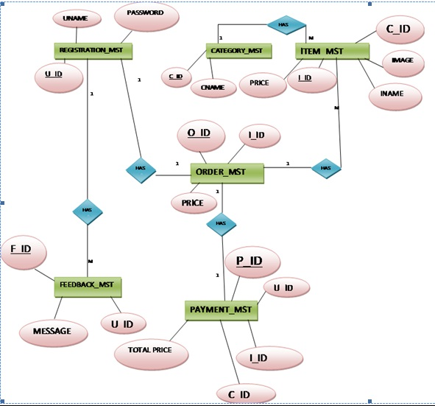

* 1. **ACTIVITY DIAGRAM**

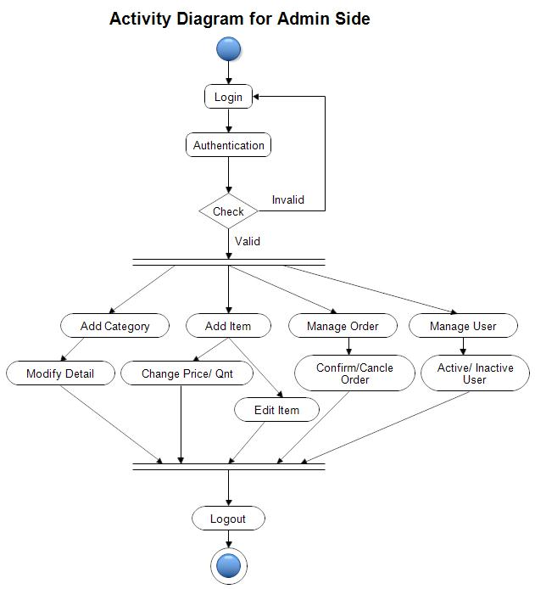

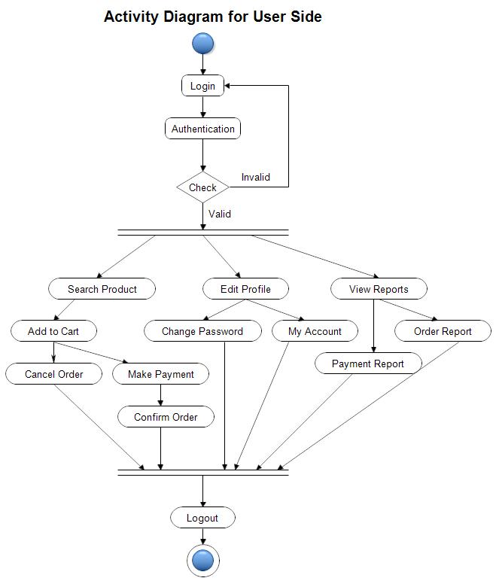

* 1. **CLASS DIAGRAM**

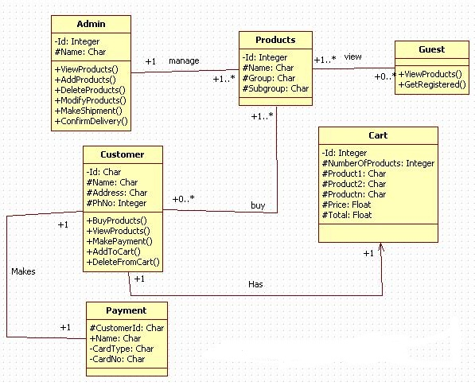

* 1. **USE CASE DIAGRAM**

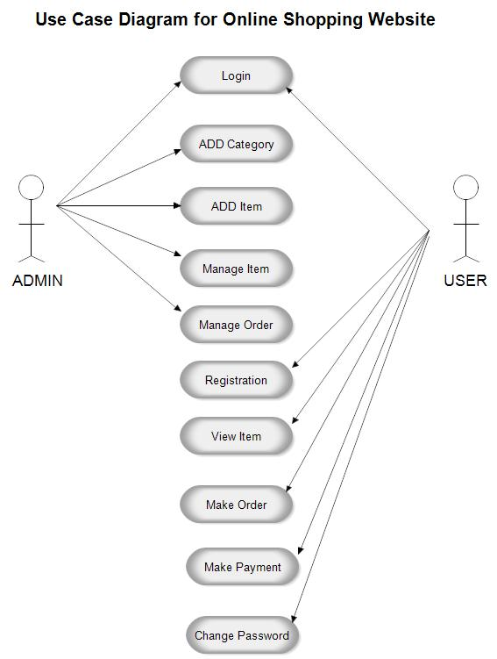

* 1. **SEQUENCE DIAGRAM**
     1. Sequence diagram for admin login

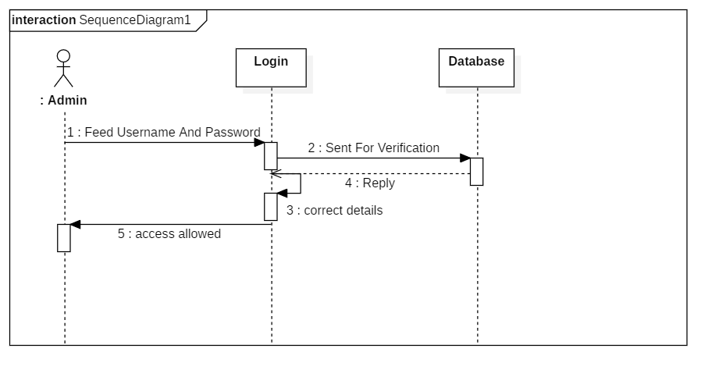

* + 1. Sequence diagram for user login

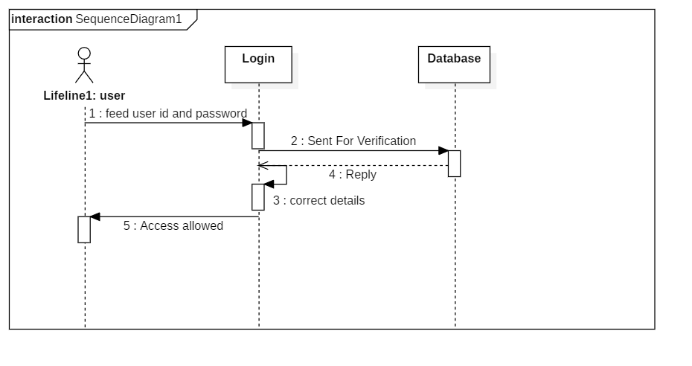

* + 1. Sequence diagram for order placement

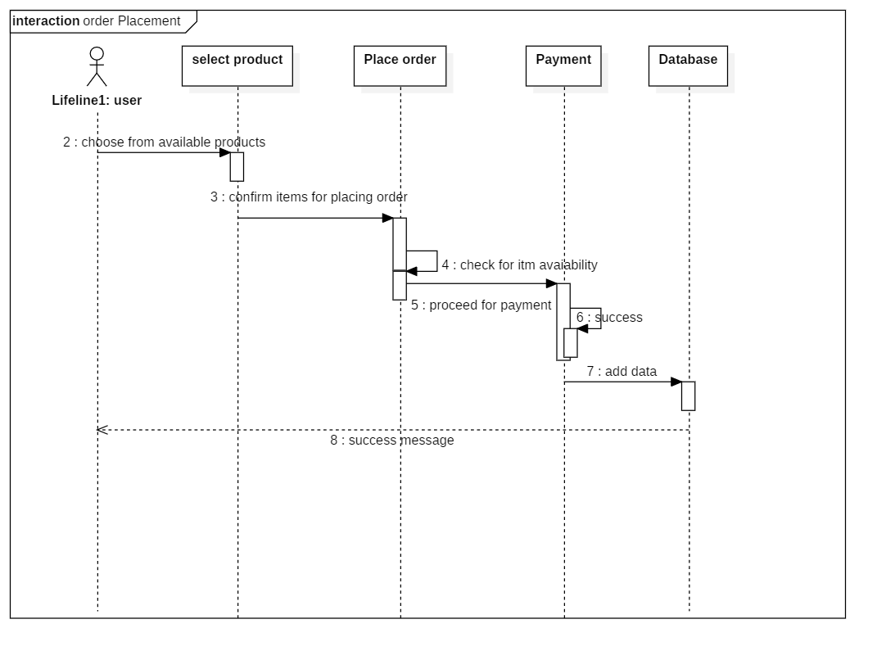

* + 1. Sequence diagram for payment process

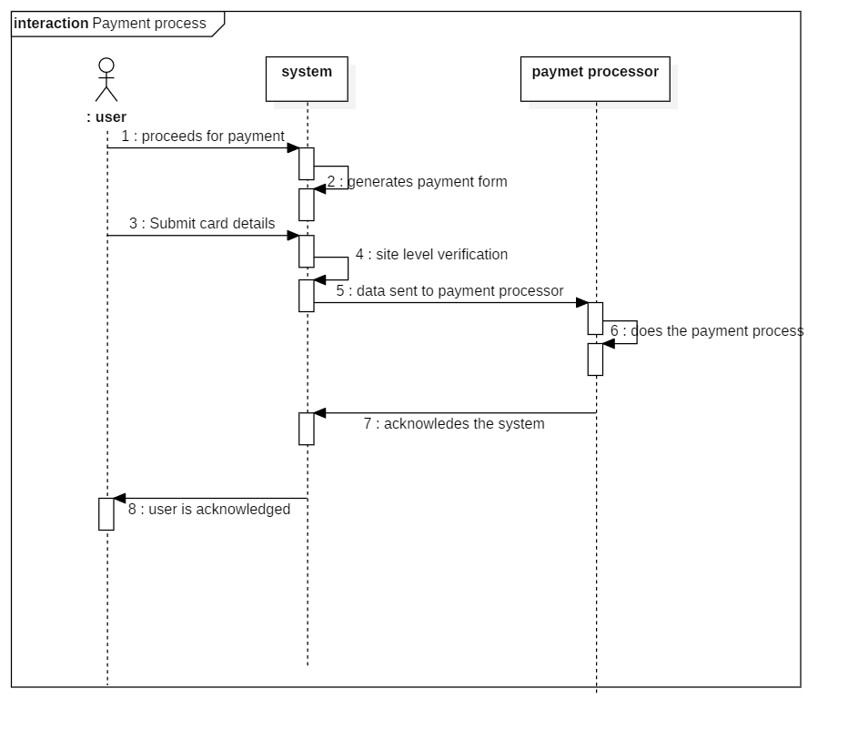

* 1. **DATA FLOW DIAGRAM**

4.6.1 DFD Level 0 (Context Level Diagram)

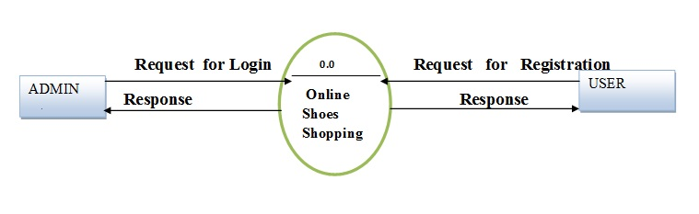4.6.2 DFD Level 1

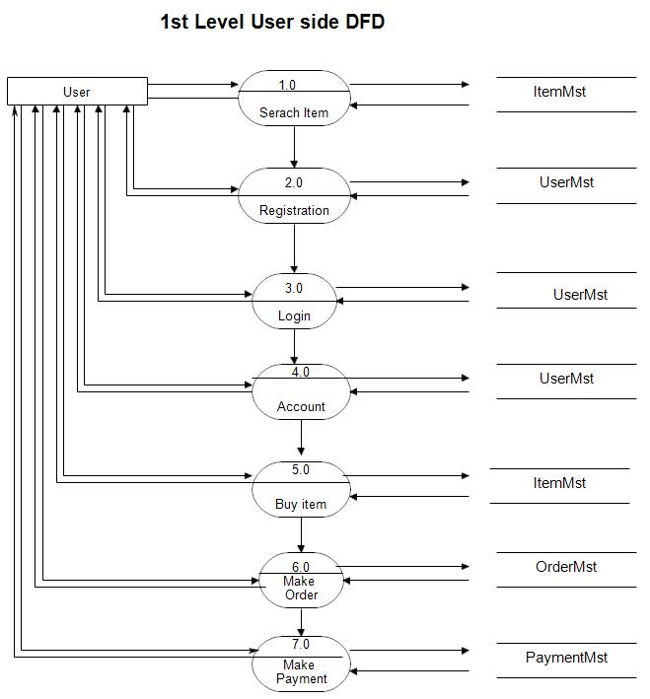

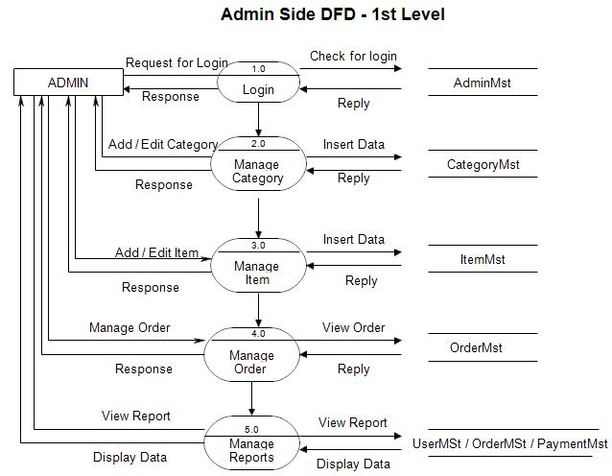

4.6.3 DFD Level 2

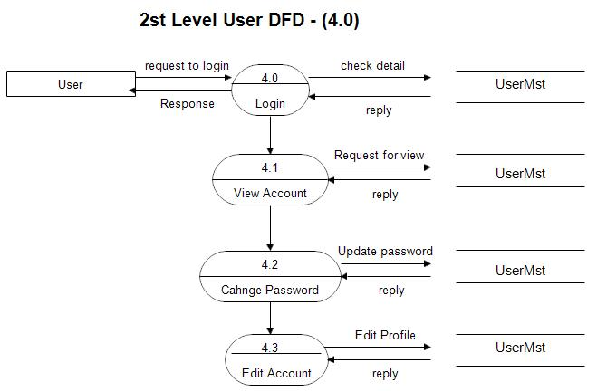

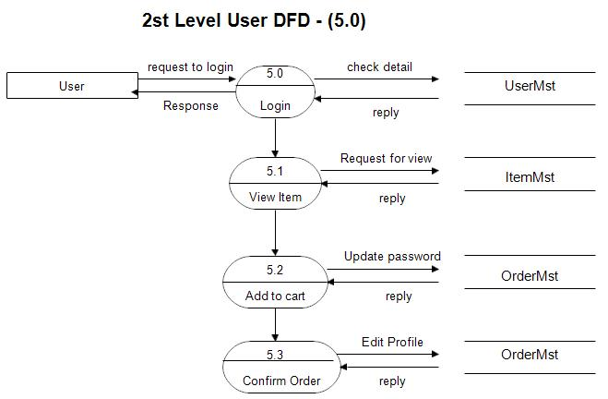

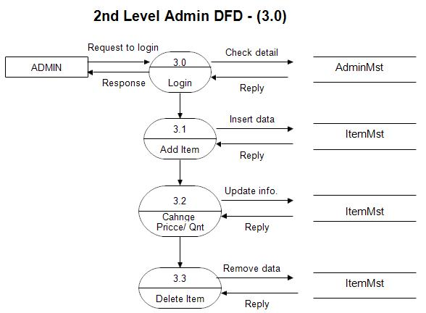

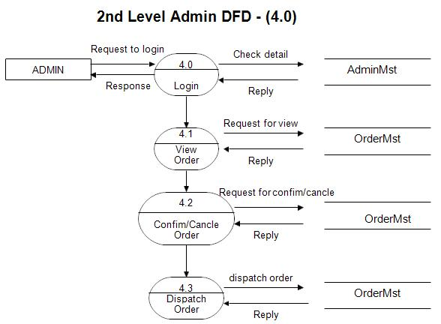

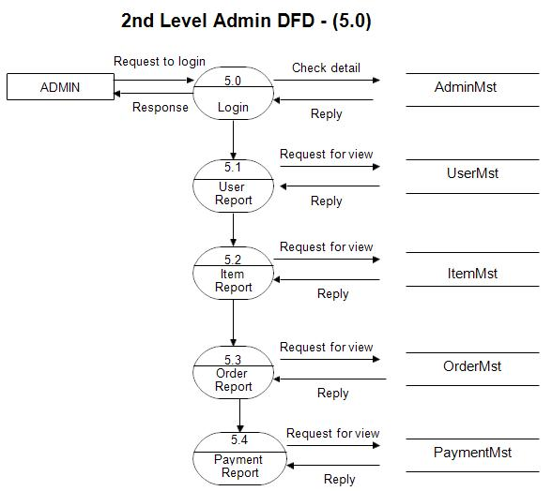

* 1. **COMPONENT DIAGRAM**

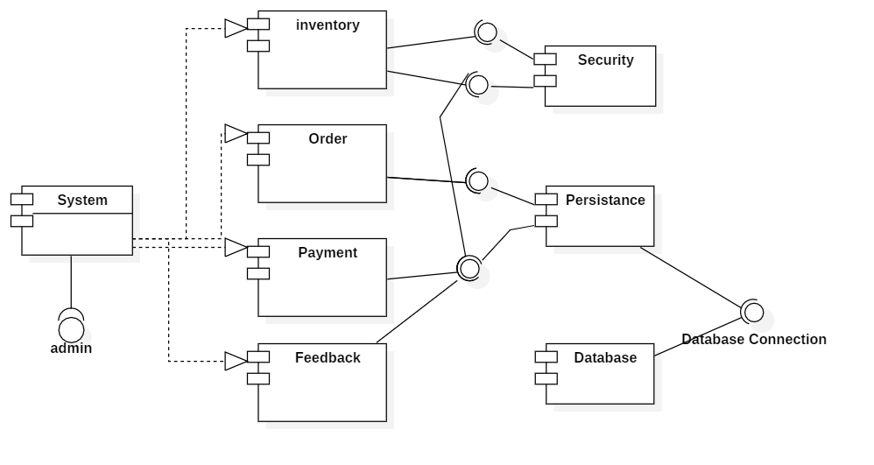

* 1. **DEPLOYMENT DIAGRAM**

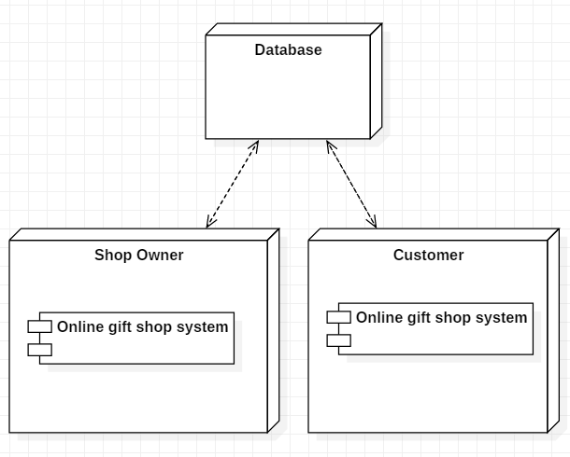

**4.9 DATA DICTIONARY**

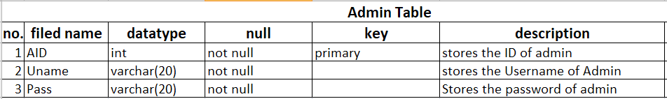

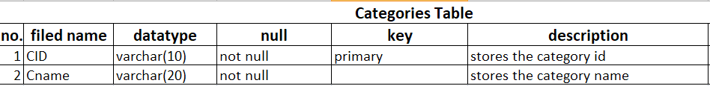

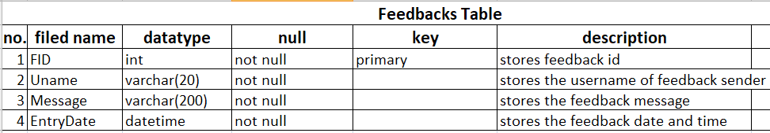

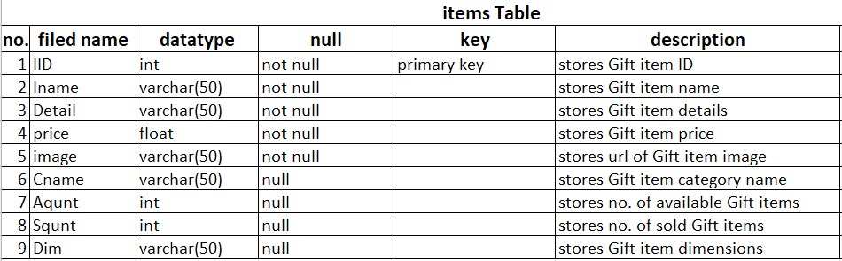

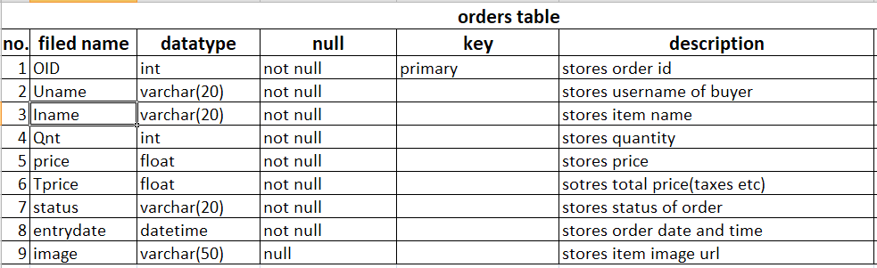

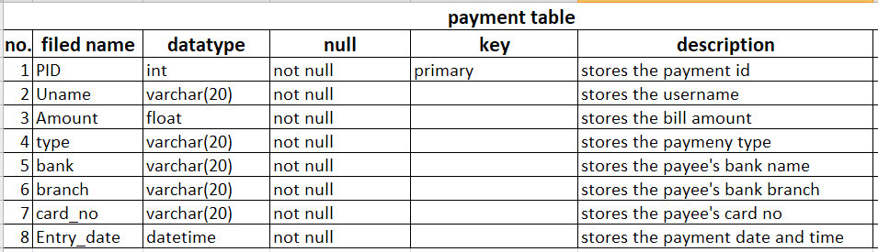

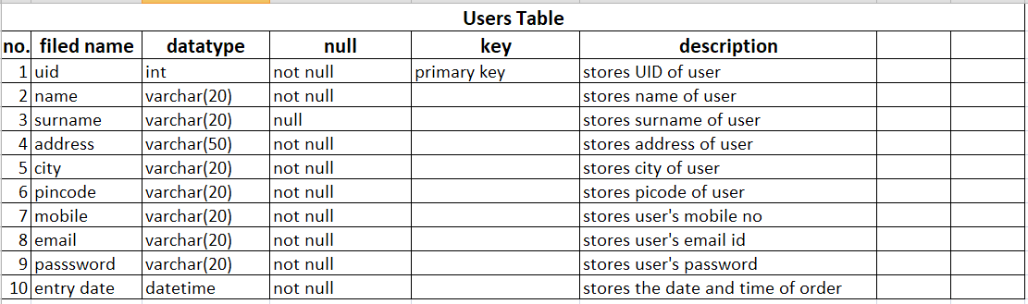

**System Validation**

**Unit Testing:**

Unit testing, a testing technique using which individual modules are tested to determine if there are any issues by the developer himself. It is concerned with functional correctness of the standalone modules. The main aim is to isolate each unit of the system to identify, analyse and fix the defects. For example, the log in/registration module would be programmed to consist of 5-10 characters. Through Unit Testing, the developer would be able to establish that to log into the system, user has to input 5-10 characters. Only after each unit is tested successfully.

**Integration Testing:**

Integration Testing is a level of software testing where individual units are combined and tested as a group. The purpose of this level of testing is to expose faults in the interaction between integrated units.

**System Testing:**

System Testing is usually carried out by a team that is independent of the development team in order to measure the quality of the system unbiased. It includes both functional and NonFunctional testing. The developer would have to test the whole system thoroughly at this stage and assure each and every function of the system is working as expected.

**User Acceptance Testing:**

User Acceptance Testing is initiated with user stories and user requirements. At this stage,

the developer would more concentrate on the business acceptance criteria rather than waiting till the final implementation. The developer has framed out a user acceptance test for system that involves user interactions at the end of each unit test. the system is thoroughly tested, the developer would ask actual users such as doctors, nurse, patients to test the system and their

response would be collected. Their opinion would be evaluated in the scale of:

1 = Poor, 2 = Fair, 3 = Good, 4 = Very Good, 5 = Excellent.

**References and Bibliography:**

**1. Books referred:**

* Murach’s Asp.net Programming
* Beginning ASP.NET 4.5
* HeadFirst Android Development
* Learning Android Application development
* Database System Concepts

**2. Websites Referred:**

* TutorialsPoint.com
* Developer.android.com
* Udacity.com
* Codementor.com

**3. Softwares Used:**

* Visual studio 2017
* Android Studio 3.1
* Mysql 5.1
* StarUML 3.2

THANK YOU